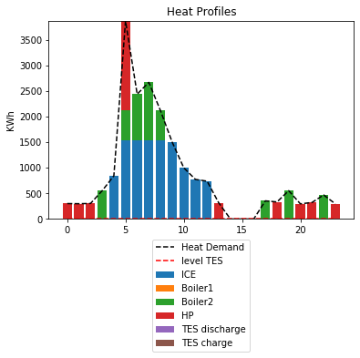

This graph shows the heat profile of our multiple energy system in a summer day.

In this case we have no thermal storage systems that can be seen in the graph where the red dashed line lies on the horizontal axis.

The blue bars represent the power produced by the internal combustion engine. From this it can be deducted that for some periods of time and in some hours in a day the production of ICE is not enough to fulfill the heat demand. That's where the boilers and the heat pump come into action to help us fill this gap.

Boiler1 represented with the orange color is never used; the reason of which maybe that boiler 1 is not running as efficiently and as economically as boiler 2. For example, sometimes we prefer to use the heat pump instead of boiler 1 to fulfill this need. Also we can see that in some hour instead of activating the boiler we are using the heat pump and that may be caused by the fact that in some hours specially early hours in the morning or late hours at night the price of electricity is cheap and that makes using heat pump instead of Boilers more economic. The other point is that when the heat demand is too low, we avoid turning on the ICE at all. Starting an ICE, is not economical at low loads since the efficiency curve for the combustion engines reaches its maximum in a specific load; This makes using ICEs at low loads too costly.

In the hours in the afternoon which are the hottest hours of a day in the summer there is no heat usage for about 3 hours and those hours are in the afternoon. The peak of hit demand is at night which makes reasonable because we have the coldest hours then. Also, there is a small peak in the evening which may be the time that people get back home.

After all, we have no TES discharge and TES charge as in this case we have no Thermal Storage system.

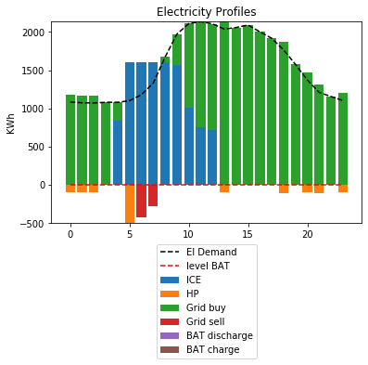

This graph shows the electricity profile of our multiple energy systems for a day in summer.

As also can be seen from almost all the electricity demand curves, we have a peak during the morning due to working activities, and a peak in the evening hours. But also, in this case we have pick in the afternoon because those are the hottest hours in a day in summer and maybe in our systems there are active electricity consuming conditioning devices, increasing the overall electricity demand.

Displayed in orange is the electricity demand by the heat pump which as described in the heat demand part is mostly active in the morning hours or late hours at night. the contributed values in this section are negative because it is considered as consumption whereas in the heat profiles it is a production with a positive sign.

For most of the hours it is not economic to produce electricity; therefore, most of the hours in the day are displayed with the green bars which represents the electricity bought from the grid. Only in few hours in the morning we are selling electricity to the grid I.e. the surplus of the production of our internal combustion engine. First probable cause is that maybe in those hours, high electricity price makes it interesting to produce more power than needed and then selling it to the grid. The other reason may be that the efficiency of our internal combustion engine is low at our real-time demand which makes us go for even producing a higher production to optimize the efficiency of our ICE and therefore reducing its operating cost.

Also, in this case there are no bars represented with purple or brown as we don't have any storage system.

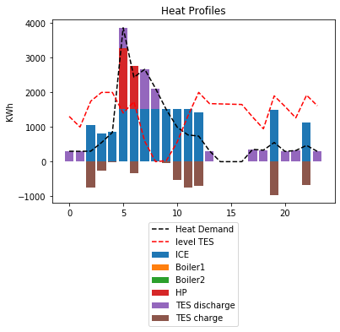

This is the heat profile of the second case where we have 2000 Kwh of thermal storage, and no battery storage installed.

As expected, the trend of heat demand generally opposes the heat storage since in those hours it is more interesting to use all the heat that we have generated to fulfill our demand.

Compared to the time where we had no thermal storage systems, we can see that we also turn on the ICE at night maybe because in those hours it is more convenient to store the thermal capacity since it gets cold in the first hours of the night and those thermal energy stored earlier could be useful .

We can see that in early hours of the morning we're turning on our heat pumps. Even in one hour we're turning heat pump on only to charge our thermal storage system. The reason maybe that in that hour, the electricity is cheaper which makes using electricity for generating and storing heat cheaper than producing it real-time in the next hours.

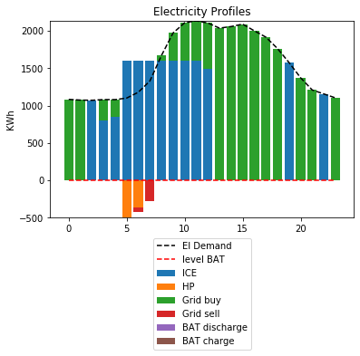

This figure shows the electricity profile of the case where we have no electrical storage and 2000 Kwhs of heat storage. As can be seen the internal combustion engine is active in the same hours that we have seen before and for the rest of the times we're using buying electricity from the grid the reason had been explained in the previous case and is similarly applicable to this case.

in early hours in the morning we're turning on ICE just for the reasons like the previous case, in addition to need for generating and storing heat.

Almost nothing new happens here because we have no electrical storage system but in the hours that we are storing heat mostly in the morning, the demand for electricity is sometimes higher and that is maybe due to the fact that we're using electricity to generate heat.

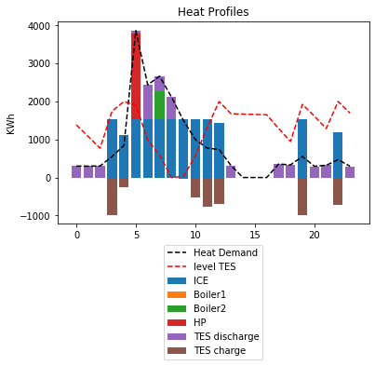

This is the case where we have both thermal an electrical storage.

Compared to the second case’s heat profile at hour 5 we no longer have the thermal energy storage discharge. This is due to the fact that here we can store electricity so in the previous hour when the electricity is cheaper we buy electricity and store it and then at hour 5 instead of releasing thermal energy we produce –on the spot- the heat load required, by using electricity that has already been stored and so this is a more efficient way to produce electricity which implies that storing electricity at hour four is cheaper than storing heat.

The other changes at hour seven we're turning on the boiler 2. That's because at hours Seven and eight we want to store some electricity. This electricity is later used in the peak hours of the morning for our electricity demand and since we have already turned on or boiler two we can use it's heat rejection to recover some parts of the energy that boiler two is producing. In summary, we are using a CHP mode in this case which has a higher efficiency than turning on the ICE to provide heat. So here we take advantage of a boiler which is already in use.

The night hours are mostly like the previous case since also in the previous case we had thermal storage; in the late hours at night we store heat and then release it in the early hours of the morning which are colder.

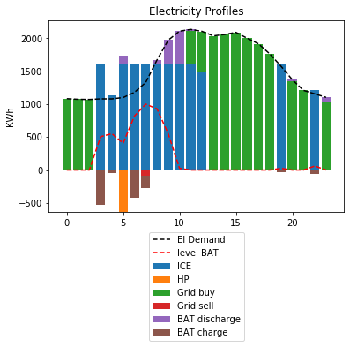

This is the electricity profile of our third case.

In terms of the operating hours of the ICE we have almost similar usage with the previous case.

The difference with the previous case is that in the early hours of the morning we store some electricity in our batteries that leads us to a reduced electricity consumption of our heat pumps since storing electricity and using the electricity later on to produce heat is a more efficient way to produce the required heat load later. That can be seen from this stored electricity bar with the brown color at the hour three and four

Later we have the electricity stored at hours six and Seven; Contrary to hours 4,5, this electricity stored is not used for producing heat, but it is used in the in the working hours of the morning, at about nine or ten to produce the electricity needed.

For the rest of the day the level of battery charge stays almost at zero. We can conclude that's storing electricity is not a good option as the most economical way is to buy electricity from the grid and since we are not producing electricity, it may be not economic to store it.

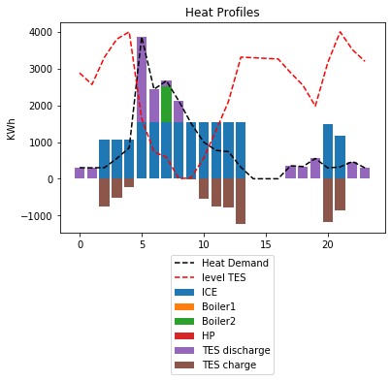

this is the fourth case in which we have an increased capacity of thermal storage and this same capacity of electricity storage.

The major difference is that the peak of hit demand in the morning is fully compensated by a discharge from our heat reserves that obliviates the need to use any electrical device or using any fuel to produce heat at that hour; so the heat pump is turned off at hour 5.

As expected, since we have an increased capacity of thermal storage, in the afternoon more heat is stored as it is not needed and, in the evening, more heat is released. this is the reason why we have a decreased load on our ICE at the final hours of the day. All the above-mentioned reasons help us store more heat later at night compared to the previous case and in the early hours of the next morning we have more heat reserves to be used.

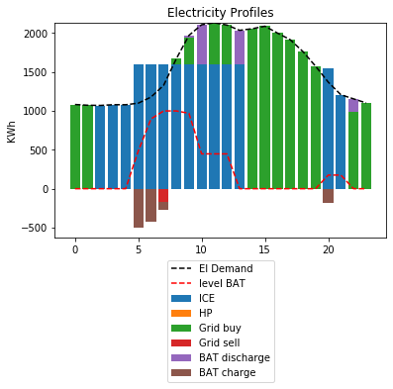

This is the electricity profile of the fourth case where we have higher heat storage capacity but still, we have the same electrical storage capacity as the previous case.

The major difference with the previous case is that the operating hours of the ICE in this case is increased and therefore less electricity is bought from the grid in this second part of the day; that is due to the fact that we have thermal storage capacity in the evening and in the afternoon and since using the stored heat capacity is cheaper than producing heat capacity at the spot, it makes it cheaper to use our boilers to provide heat to be stored. So, we already have turned on our boilers in the afternoon to store some heat and therefore we also use the electricity generated to compensate also our electricity demand. It should be noted that in the previous case it was cheaper to buy the electricity from the grid. This may also be the case here but we know that the boiler is already being used and overall if we sum up the price of the electricity that is produced and the heat that is stored which is used later we have a reduced cost compared to separately buying the electricity in the afternoon for electricity demand and in the morning to provide heat load.